

Laois and Offaly ETB

Programme Module for
Using Common Computer Applications

leading to
Level 4 QQI
Computer Applications 4N1112

Version Log for this Component
The most recent change and version is highlighted and listed first. This is the version you should use in your delivery of the component.

Version | Effective Date | Change
04 | 1st Sept 2022 | Replaced the word ‘spreadsheet’ with ‘document’ in final assessment criterion for Graphics.  Remove reference to MS PowerPoint as a graphics package in Indicative Content.  Inclusion of component version log.
03 | 1st Sept 2020 | Formatting only
02 | 8th Feb 2018 | EA Signature on Marking Sheet

Introduction
This programme module may be delivered as a standalone module leading to certification in a QQI minor award. It may also be delivered as part of an overall validated programme leading to a Level 4 QQI Certificate.
The teacher/tutor should familiarise themselves with the information contained in the Laois and Offaly ETB’s programme descriptor for the relevant validated programme prior to delivering this programme module.
The programme module is structured as follows:
- Title of Programme Module
- QQI Component Title and Code
- Duration in hours
- Credit Value of QQI Component
- Status
- Special Requirements
- Aim of the Programme Module
- Objectives of the Programme Module
- Learning Outcomes
- Indicative Content
- Assessment
  - Assessment Technique(s)
  - Mapping of Learning Outcomes to Assessment Technique(s)
  - Guidelines for Assessment Activities
- Grading
- Learner Marking Sheet(s), including Assessment Criteria

Integrated Delivery and Assessment
The teacher/tutor is encouraged to integrate the delivery of content where an overlap between content of this programme module and one or more other programme modules is identified. This programme module will facilitate the learner to develop language, literacy and numeracy skills relevant to the themes and content of the module.

Likewise the teacher/tutor is encouraged to integrate assessment where there is an opportunity to facilitate a learner to produce one piece of assessment evidence which demonstrates the learning outcomes from more than one programme module. The integration of the delivery and assessment of level 4 Communications and level 4 Mathematics modules with that of other level 4 modules is specifically encouraged.

Structured communication and teamwork is encouraged between the teacher/tutor delivering this programme module and the language, literacy, numeracy and learning support teacher/tutor, as appropriate, to facilitate the learner in completing the programme module and achieving certification in the award.

Indicative Content
The indicative content in Section 10 does not cover all teaching possibilities. The teacher/tutor is encouraged to be creative in devising and implementing other approaches, as appropriate. The use of examples is there to provide suggestions. The teacher/tutor is free to use other examples, as appropriate. The indicative content ensures all learning outcomes are addressed but it may not follow the same sequence as that in which the learning outcomes are listed in Section 9. It is the teacher’s/tutor’s responsibility to ensure that all learning outcomes are included in the delivery of this programme module.

Title of Programme Module
Using Common Computer Applications

Component Name and Code
Computer Applications 4N1112

Duration in Hours
100 Hours (typical learner effort, to include both directed and self directed learning)

Credit Value
10 Credits

Status
This programme module may be compulsory or optional within the context of the validated programme. Please refer to the relevant programme descriptor, Section 9 Programme Structure

Special Requirements
None

Aim of the Programme Module
This programme module aims to provide the learner with the personal knowledge, skills and capacity to effectively use a range of common computer applications.

Objectives of the Programme Module

- To develop an understanding of the uses of database, spreadsheet and graphics software and the terminology and language appropriate to each.
- To facilitate the learner to develop the skills to use spreadsheet applications as an effective tool.
- To facilitate the learner to develop the skills to use database applications as an effective tool.
- To facilitate the learner to develop the skills to use graphics applications as an effective tool.
- To assist the learner to develop the language, literacy and numeracy skills related common computer applications through the medium of the module themes and content.

- To enable the learner to take responsibility for his/her own learning.

Learning Outcomes of Level 4 Computer Applications 4N1112
Learners will be able to:
- Explain database and how database systems are used in organisations
- Describe the structure of a database
- Describe the structure of a spreadsheet
- Identify applications suitable for spreadsheets
- Identify applications suitable for graphics software
- Use the terminology appropriate to database software, spreadsheet software and graphics software accurately
- Use database software to create a database file to include enter and edit data, add new records, delete individual records, add new field to existing record and save
- Use spreadsheet software to create a spreadsheet to include enter and edit numeric and character data
- Modify a spreadsheet by inserting and deleting rows and columns, adjusting column widths and formatting column entries
- Use graphics software to create drawings to include clipart, colour, shape, size, text, enhance text
- Operate the database effectively by browsing, querying and sorting the database on a single field
- Apply a range of formulae and functions over a range of cells using relative cell references to include mathematical operators, SUM and AVERAGE functions
- Produce a hard copy of drawings modified using colour, shape and size.

Indicative Content
This section provides suggestions for programme content but is not intended to be prescriptive. The programme module can be delivered through classroom based learning activities, group discussions, one-to-one tutorials, field trips, case studies, role play and other suitable activities, as appropriate.
Section 1 : Database
Understanding Databases
- Explore with the learner :
- A database is a system for organizing data. It is a collection of raw data that can be manipulated, sorted, and queried to produce information. The data can be stored in many ways. Before computers, card files, printed books and other methods were used. Now most data is kept on computer files.
- A database system is a computer program for managing electronic databases. A very simple example of a database system would be an electronic address book
    - Consider with the learner some commonly used terms and terminology associated with a Database application, for example:
  - Table
  - Field
  - Record
  - Query
  - Form
  - Sort
  - Datatype
  - Primary Key
  - Design View
  - Datasheet View
  - Database Management System

Using the Database application
Facilitate the learner to use a Database application to produce a Database that may be used for work and personal purposes, for example, a contacts list, an inventory system, an employee system, other Database of interest to the learner.
- Review with the learner the file handling icons associated with a Database application, and their functions, for example:
- Open
- Save
- Save As
- New
- Close
- In producing these Database carry out the following steps:
  - Access the Database application
  - Create a database
  - Design and setup a table
  - Enter data
  - Sort the data
  - Print the table
  - Store the file for subsequent retrieval
  - Create a query
  - Close the application correctly

Accessing the Database application
Complete the following tasks with the learner:
- Access the Database application, for example, Microsoft Access
- Access the application from a shortcut on the desktop and from the Start Menu

Setting up the Table
Complete the following tasks with the learner:
- Enter Design View
- Determine the fields required for the table
- Select an appropriate datatype for each field

Entering Data and Record Management
Complete the following tasks with the learner:
- Enter Datasheet View
- Enter data into an existing Database table
- Use the mouse and the arrow direction keys to control the active cell on the Database and to get to where the learner wants to enter data
- Enter data using the keyboard, for example, text and numeric data
- Use the Caps Lock, Shift Key and Num Lock to enter capital letters, symbols and numbers
- Add a new record
- Delete an existing record

Searching and Sorting the Database
Complete the following tasks with the learner:
- Use the sort facility to sort the data on a given field in a given order.
- Use the find facility to a value in a table.
- Use the find and replace facility to change a particular value in a table.

Creating Queries
Complete the following tasks with the learner:
- Use the query design facility to create a simple query on a particular table
- Save the query for future access using an appropriate name

Printing the Database
Complete the following tasks with the learner:
- Print Preview the Database before printing them
- Print the Database and consider printer settings, for example
  - Select the appropriate printer to use
  - Select the number of copies needed
  - Select the print range and sheets to be printed, for example, active sheets or entire workbook

Storing the Database for subsequent retrieval
Complete the following tasks with the learner:
- Use the Save As function to save the database on a portable device, for example, a memory stick or a CD
- Outline the different locations, in addition to saving to portable devices, where Database may be saved, for example to the Desktop or to a folder on the Hard Drive
- Discuss the importance of giving the database an appropriate File Name, for example, to differentiate between different drafts of a Database, for ease of retrieval and for speed in retrieving the Database
- Consider the different “Save as type” formats available in the Database application, for example, Access 2002-2003 Database
- Close the database once it has been saved

Exiting the Database Application
Complete the following task with the learner:
- Exit the Database Application, for example, using the Close (Quit) button or by using the Exit option in the application

Section 2: Spreadsheets

Understanding Spreadsheets
- Explore with the learner :
  - The use a Spreadsheets application, for example, A Spreadsheet is a computer program that imitates a paper worksheet. It shows a large sheet (like a sheet of paper) that has many cells in a grid of rows and columns. Users can put words or numbers into the cells, to make headings and store information (usually numbers).
  - The primary reason most people use spreadsheets, is for automatic calculations. Spreadsheets can be designed to add up the items/amounts on a bill, calculate totals, averages, percentages etc. A user can add and subtract the numbers here, even if the numbers are not next to each other. This means the computer does the math, and people only need to give the correct information.
- Consider with the learner some commonly used terms and terminology associated with a Spreadsheets application, for example:
- Toolbars
- Icons
- Workbook and Worksheet
- Column
- Row
- Cell
- Value
- Label
- Formula
- Number Format
- Print preview

- Review with the learner the file handling icons associated with a Spreadsheets application, and their functions, for example:
- Open
- Save
- Save As
- New
- Close

Using the Spreadsheets application
Facilitate the learner to use a Spreadsheets application to produce spreadsheets that may be used for work, personal or social purposes, for example, a timetable, a personal budget, a bill, a wages calculation, a tax calculation, timeline, record of activities or other spreadsheets of interest to the learner
- In producing these spreadsheets carry out the following steps:
  - Access the Spreadsheets application
  - Set up the page
  - Enter data
  - Edit and Format the text and table layout to enhance its appearance
  - Print the spreadsheets
  - Store the file for subsequent retrieval
  - Close the application correctly

Accessing the Spreadsheets application
Complete the following tasks with the learner:
- Access the Spreadsheets application, for example, Microsoft Excel or Microsoft Works Spreadsheet
- Access the application from a shortcut on the desktop and from the Start Menu

Setting up the Page
Complete the following tasks with the learner:
- Adjust column and row widths and heights as appropriate
- Alternate between page orientations for different spreadsheets, as appropriate, for example, Landscape and Portrait

Entering Data
Complete the following tasks with the learner:
- Enter data into a new spreadsheet
- Enter data into an existing spreadsheet
- Use the mouse and the arrow direction keys to control the active cell on the spreadsheet and to get to where the learner wants to enter data
- Enter data using the keyboard, for example, text and numeric data
- Use the Caps Lock, Shift Key and Num Lock to enter capital letters, symbols and numbers

Formatting the text to enhance its appearance
- Review with the learner the commonly used Spreadsheets icons and their functions, to include:
    - Cut
    - Copy
    -  Paste
    - Bold
    - Italic
    - Underline
    - Font Name
    - Font Size
    - Increase and Decrease Font
    - Font Colour
    - Text Highlight Colour
    - Text and Image Alignment
    - 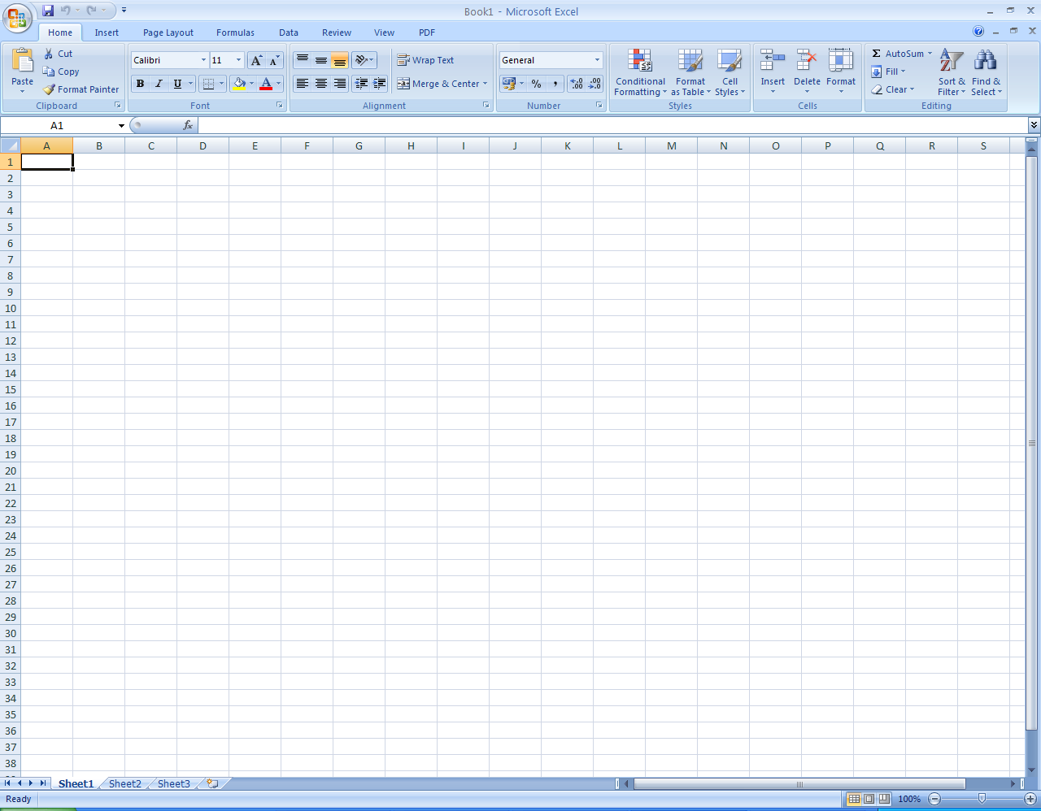 Wrap Text
    - Merge & Centre
- Facilitate the learner to use these icons to format spreadsheets to improve their appearance and clarity
- Facilitate the learner to:
    - Use the mouse and the arrow direction keys to control the active cell and to get to where the text is to be formatted
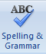
    - Use the Delete key to delete data from the spreadsheets
    - Use the Spelling and Grammar check in the Spreadsheets application and make any necessary changes to the document
    - Proof read the spreadsheets to ensure correct spelling, grammar and meaning

Applying formulae
Complete the following tasks with the learner:
- Enter an addition formulae into an appropriate cell in a spreadsheet
- Enter a subtraction formulae into an appropriate cell in a spreadsheet
- Enter a multiplication formulae into an appropriate cell in a spreadsheet
- Enter a division formulae into an appropriate cell in a spreadsheet
- Enter a SUM formulae into an appropriate cell in a spreadsheet
- Enter an AVERAGE formulae into an appropriate cell in a spreadsheet
- Explore how to fill, copy and replicate formulae in a spreadsheet

Printing the spreadsheets
Complete the following tasks with the learner:
- Print Preview the spreadsheets before printing them
- Print the spreadsheets and consider printer settings, for example
  - Select the appropriate printer to use
  - Select the number of copies needed

Storing the document for subsequent retrieval
Complete the following tasks with the learner:
- Use the Save As function to save the document on a portable device, for example, a memory stick or a CD
- Outline the different locations, in addition to saving to portable devices, where spreadsheets may be saved, for example to the Desktop or to a folder on the Hard Drive
- Discuss the importance of giving the document an appropriate File Name, for example, to differentiate between different drafts of a spreadsheet, for ease of retrieval and for speed in retrieving the spreadsheet
- Consider the different “Save as type” formats available in the Spreadsheets application, for example, Excel Workbook, Excel 97-2003 Workbook, CSV (Comma delimited)
  - Save a document using these 3 different “Save as type” formats
  - Compare the different versions of the document to see how the “Save as type” selected has modified the document
- Use the Save function to systematically and periodically save work as it is being produced
- Outline the reasons for, and the value of, backing up data to a removable storage device
- Close the document once it has been saved

Exiting the Spreadsheets Application
Complete the following task with the learner:
- Exit the Spreadsheets Application, for example, using the Close (Quit) button or by using the Exit option in the application

Section 3: Graphics

Understanding Graphics
- Explore with the learner :
  - A Graphics application is a computer program that enables a person to create or manipulate visual images on a computer.
  - The use of a Graphics application, for example a graphics application can used to draw a picture, create a poster and edit a photograph.
  - A common Graphics application, for example Microsoft Paint, Adobe Photoshop, Corel Paint Shop Pro, GIMP and JPhotoBrush Pro.
- Consider with the learner some commonly used terms and terminology associated with a Graphics application, for example:
  - Toolbars
  - Icons
  - Colour
  - Clipart
  - Shape
  - Size
  - Text
  - Print preview

- Review with the learner the file handling icons associated with a Graphics application, and their functions, for example:
- Open
- Save
- Save As
- New
- Close

Using the Graphics application
Facilitate the learner to use a Graphics application to produce or modify drawings using colour, shape, size, text and clipart.
- In producing these drawings carry out the following steps:
  - Access the Graphics application
  - Use a range of drawing tools contained in the application
  - Inserts shapes & lines of various size and colour
  - Insert Clipart
  - Insert and Format Text
  - Print the drawings
  - Store the file for subsequent retrieval
  - Close the application correctly

Accessing the Graphics application
Complete the following tasks with the learner:
- Access the Graphics application, for example, Microsoft Paint, Adobe Photoshop, Corel Paint Shop Pro, GIMP and JPhotoBrush Pro.
- Access the application from a shortcut on the desktop and from the Start Menu

Formatting the text to enhance its appearance
- Review with the learner the commonly used text formatting icons and their functions, to include:
  - Bold
  - Italic
  - Underline
  - Font Name
  - Font Size
  - Increase and Decrease Font
  - Font Colour
  - Text Highlight Colour
  - Text and Image Alignment

Printing from the Graphics application
Complete the following tasks with the learner:
- Print Preview the drawings before printing them
- Print the drawings and consider printer settings, for example
  - Select the appropriate printer to use
  - Select the number of copies needed

Storing the document for subsequent retrieval
Complete the following tasks with the learner:
- Use the Save As function to save the drawing on a portable device, for example, a memory stick or a CD
- Use the Save As function to save the drawing as a different file type, e.g. JPEG or GIF
- Outline the different locations, in addition to saving to portable devices, where drawings may be saved, for example to a folder on the Hard Drive
- Discuss the importance of giving the file an appropriate File Name
- Use the Save function to systematically and periodically save work as it is being produced
- Outline the reasons for, and the value of, backing up data to a removable storage device
- Close the document once it has been saved

Exiting the Graphics Application
Complete the following task with the learner:
- Exit the Graphics Application, for example, using the Close (Quit) button or by using the Exit option in the application

Assessment
11a. Assessment Techniques
Examination Practical 100%

11b. Mapping of Learning Outcomes to Assessment Techniques
In order to ensure that the learner is facilitated to demonstrate the achievement of all learning outcomes from the component specification; each learning outcome is mapped to an assessment technique(s). This mapping should not restrict an assessor from taking an integrated approach to assessment.
Learning Outcome | Assessment Technique
- Explain database and how database systems are used in organisations | Examination – Practical
- Describe the structure of a database | Examination – Practical
- Describe the structure of a spreadsheet | Examination – Practical
- Identify applications suitable for spreadsheets | Examination - Practical
- Identify applications suitable for graphics software | Examination - Practical
- Use the terminology appropriate to database software, spreadsheet software and graphics software accurately | Examination - Practical
- Use database software to create a database file to include enter and edit data, add new records, delete individual records, add new field to existing record and save | Examination - Practical
- Use spreadsheet software to create a spreadsheet to include enter and edit numeric and character data | Examination - Practical
- Modify a spreadsheet by inserting and deleting rows and columns, adjusting column widths and formatting column entries | Examination - Practical
- Use graphics software to create drawings to include clipart, colour, shape, size, text, enhance text | Examination - Practical
- Operate the database effectively by browsing, querying and sorting the database on a single field | Examination - Practical
- Apply a range of formulae and functions over a range of cells using relative cell references to include mathematical operators, SUM and AVERAGE functions | Examination - Practical
- Produce a hard copy of drawings modified using colour, shape and size. | Examination – Practical

11c. Guidelines for Assessment Activities
The assessor is required to devise examination papers and marking schemes for the practical examination. In devising the examination papers, care should be taken to ensure that the learner is given the opportunity to show evidence of achievement of ALL the learning outcomes.
Assessment briefs may be designed to allow the learner to make use of a wide range of media in presenting assessment evidence, as appropriate. Quality assured procedures must be in place to ensure the reliability of learner evidence.
Examination – Practical | 100%
The learner should be allowed 1 hour to complete each of the practical examinations.
- Database
The learner will complete a practical examination, requiring him/her to complete the following tasks:
- Demonstrate an understanding of how databases are used in organisations
- Demonstrate an understanding of appropriate database terminology and the structure of a database

Use database software to create a file for a suitable requirement. Database file to be a minimum of 1 table, 6 fields of various datatypes, 10 records and 3 queries. Tasks to include;
- Open the database software
- Create a database file using the appropriate data structure
- Enter and edit data
- Add and delete records
- Add a new field to an existing table
- Sort the database on a single field
- Query the database on a single field
- Print tables and queries
- Save and exit the database correctly

- Spreadsheets
The learner will complete a practical examination, requiring him/her to complete the following tasks:
- Demonstrate an understanding of suitable uses for spreadsheets
- Demonstrate an understanding of appropriate spreadsheet terminology and the structure of a spreadsheet

Use spreadsheet software to create a file for a suitable requirement. Spreadsheet files to be a minimum of 1 worksheet, 6 fields of various datatypes and 8 records. Tasks to include;
- Accessing the Spreadsheets application
- Create a spreadsheet file by entering new text (minimum of 10 labels or text) and numeric data (minimum of 30 values)into the spreadsheet in a specified location
- Insert and delete specific data and rows from the spreadsheet
- Adjusting the row height and column width of table where appropriate
- Insert formulae for basic calculations in the spreadsheet ( minimum of 6 formulae )
- Print the spreadsheet correctly
- Saving the document as a specified name exit the Spreadsheets application

- Graphics
The learner will complete a practical examination, requiring him/her to complete the following tasks:
- Demonstrate an understanding of appropriate graphics software terminology
- Demonstrate an understanding of suitable uses for graphics software

Use graphics software to create a drawing, based on a suitable requirement. Tasks to include;
- Open the graphics software
- Create a drawing by using various shapes, colours, sizes and texts
- Insert clipart into the drawing
- Format the text in the drawing
- Print a drawing correctly
- Save and exit the spreadsheet correctly

Evidence for this assessment technique may take the form of written, oral, graphic, audio, visual or digital evidence, or any combination of these. Any audio, video or digital evidence must be provided in a suitable format.

All instructions for the learner should be clearly outlined in an assessment brief and each learner is required to work alone in completing this practical examination.

Grading
Distinction: 80% - 100%
Merit: 65% - 79%
Pass: 50% - 64%
Unsuccessful: 0% - 49%

At levels 4, 5 and 6 major and minor awards will be graded. The grade achieved for the major award will be determined by the grades achieved in the minor awards.
Computer Applications 4N1112 | Learner Marking Sheet  Examination – Practical 100%
Learner’s Name: ________________________________
Assessment Criteria | Maximum Mark | Learner Mark
Database (35 Marks)  - Demonstrate an understanding of how databases are used in organisations  - Demonstrate an understanding of appropriate database terminology and the structure of a database | 10
- Open the database software  - Create a database file using the appropriate data structure  - Enter and edit data  - Add and delete records  - Add a new field to an existing table  - Sort the database on a single field  - Query the database on a single field  - Print tables and queries  - Save and exit the database correctly | 25
Spreadsheets (35 Marks)  - Demonstrate an understanding of suitable uses for spreadsheets  - Demonstrate an understanding of appropriate spreadsheet terminology and the structure of a spreadsheet | 10
- Open the spreadsheet software  - Create a spreadsheet file by entering and editing numeric and character data  - Enter and edit data  - Insert and delete rows and columns  - Adjust column widths appropriately  - Format column entries, both label and value data, appropriately  - Apply a range of formulae and functions, including mathematical operates (+,-,*,/) and SUM and AVERAGE functions  - Print a spreadsheet correctly  - Save and exit the spreadsheet correctly | 25
Graphics (30 Marks)  - Demonstrate an understanding of appropriate graphics software terminology  - Demonstrate an understanding of suitable uses for graphics software | 10
- Open the graphics software  - Create a drawing by using various shapes, colours, sizes and texts  - Insert clipart into the drawing  - Format the text in the drawing  - Print a drawing correctly  - Save and exit the document correctly | 20
Total Mark | 100

NO ROUNDING OF MARKS
The Assessor has signed the Summary Results Sheet to verify that the evidence presented in the attached portfolio is the work of the named learner and that the marks awarded here have been transcribed to the Summary Results Sheet

External Authenticator’s Signature: ____________________________ Date: _______________

